LAB #8
Efe Emir Cesur
Student ID #: 22608
Lab Section : A
1. Introduction
In this experiment, the primary goal is to integrate multiple electronic sub-blocks to design and implement an amplitude modulation radio receiver. The laboratory session aims to collectively demonstrate the practical applications of electronic components such as resistors, inductors, capacitors, diodes, and operational amplifiers. Furthermore, the experiment focuses on processing a 175 kHz carrier signal through sequential stages of filtering, amplification, and demodulation. To understand the circuit behaviors observed in this lab, theoretical information regarding the system sub-blocks is provided:
Tuner: This circuit acts as a band-pass filter, utilizing a parallel inductor-capacitor combination to resonate at the target frequency and isolate the desired broadcasting signal from the antenna.
Amplification Stages: Cascaded operational amplifiers provide the necessary voltage gain for the weak input signal. Multiple stages are used to achieve high overall gain while maintaining an adequate frequency bandwidth.
Detector: This block uses a germanium diode to rectify the amplitude-modulated signal and a capacitor to filter out the high-frequency carrier, successfully extracting the baseband audio signal.
Last Amplifier: Amplifies signal voltage to 5 Volt to make speaker work.
2. Pre-Lab Work
For the pre-lab work, I designed a parallel LC circuit of resonant frequency at 175 kHz using L = 8.2 μH as a tuner circuit. Also I designed three cascaded non-inverting amplifiers each having a gain of 5.
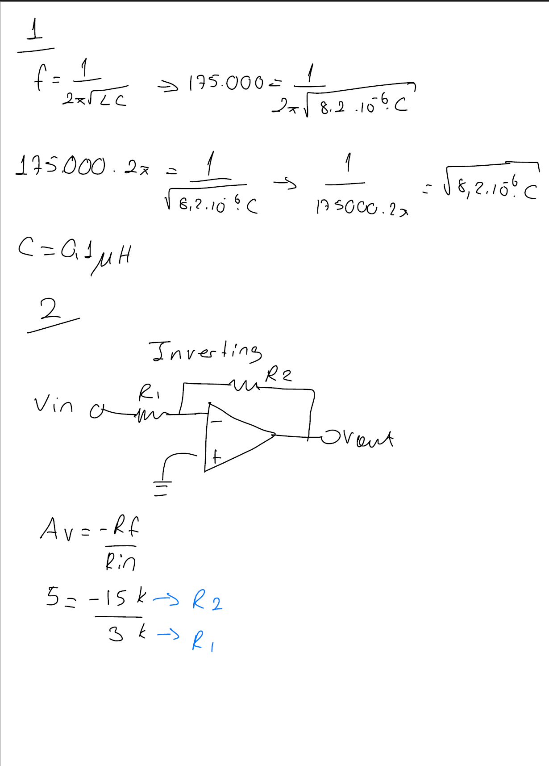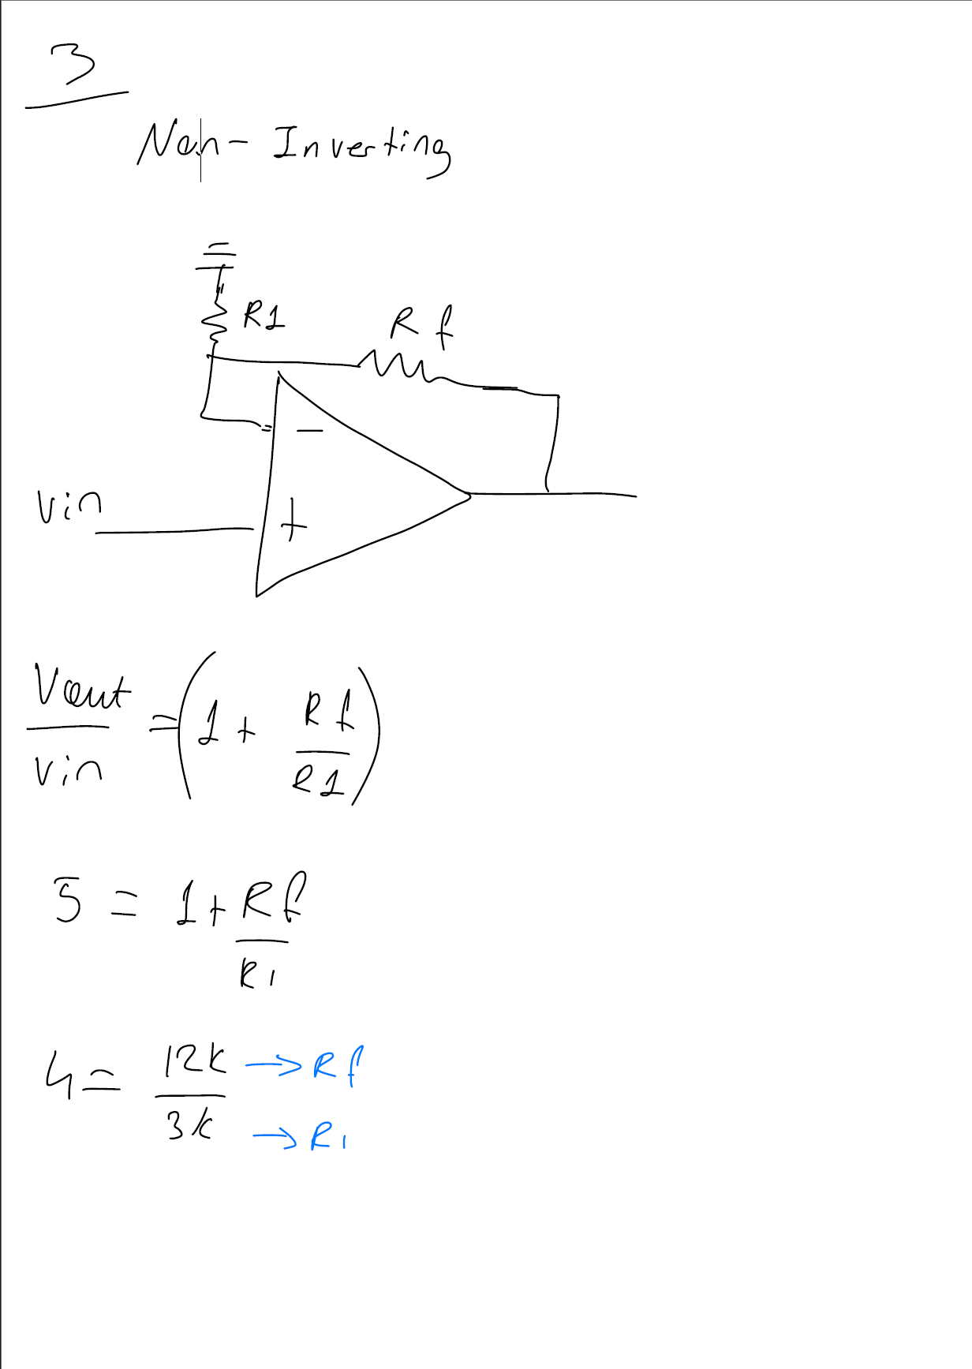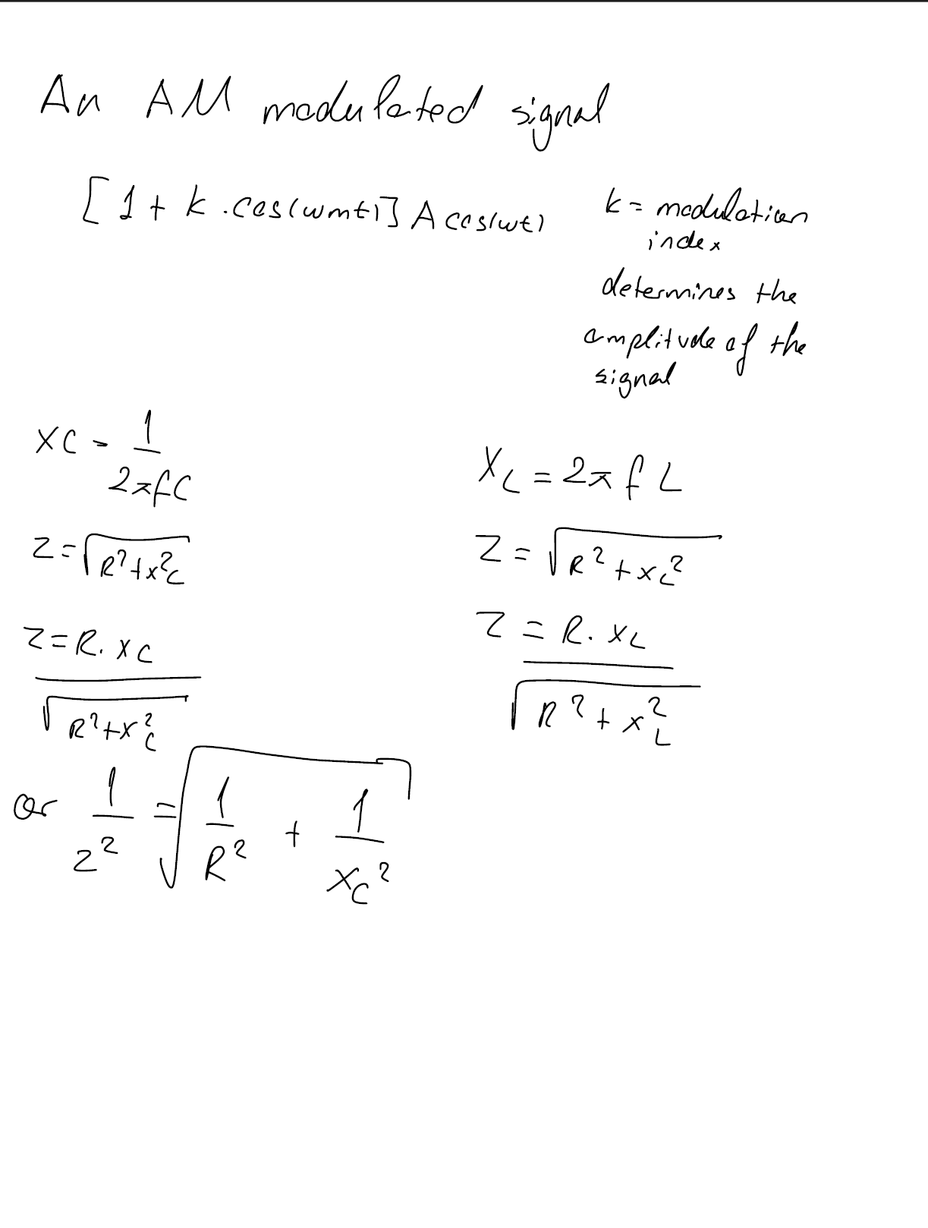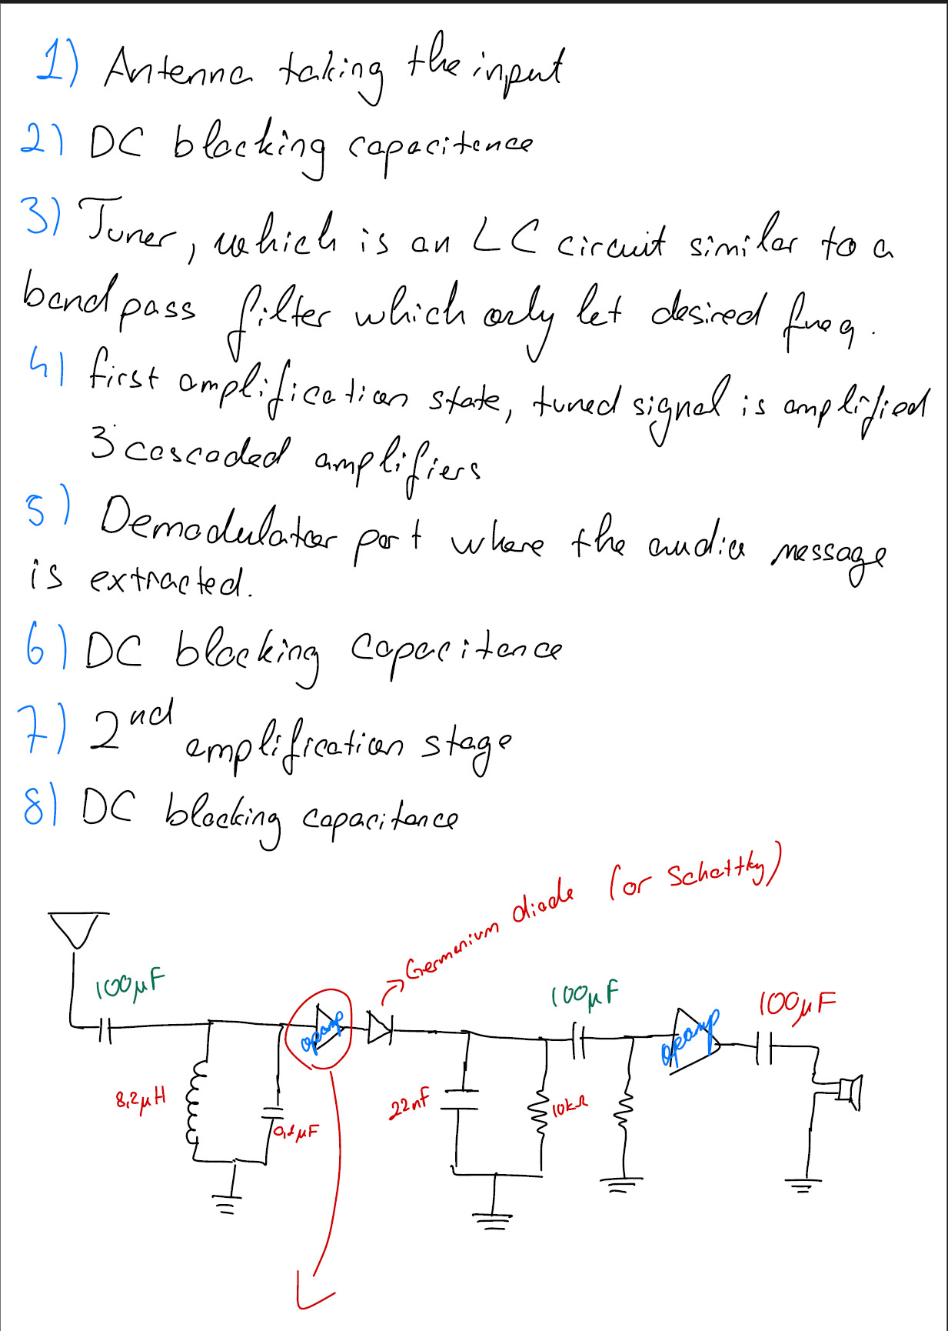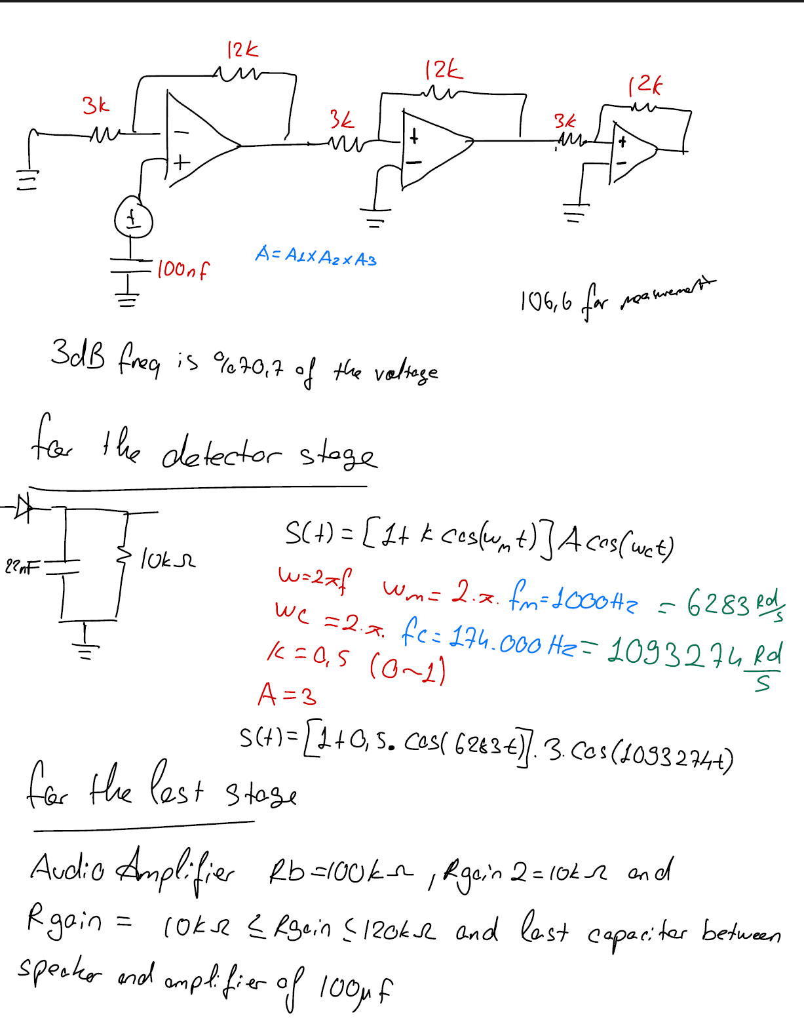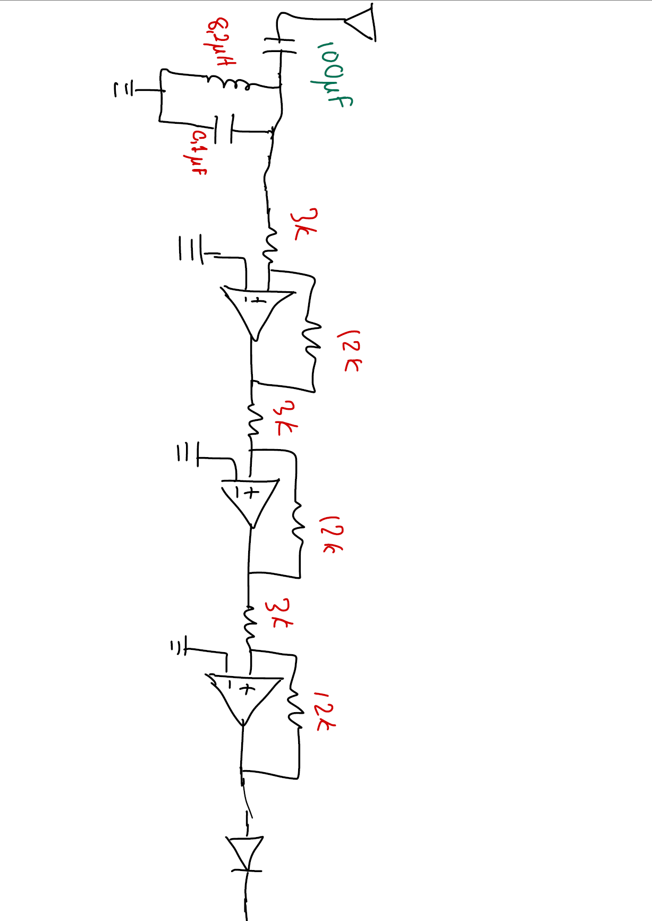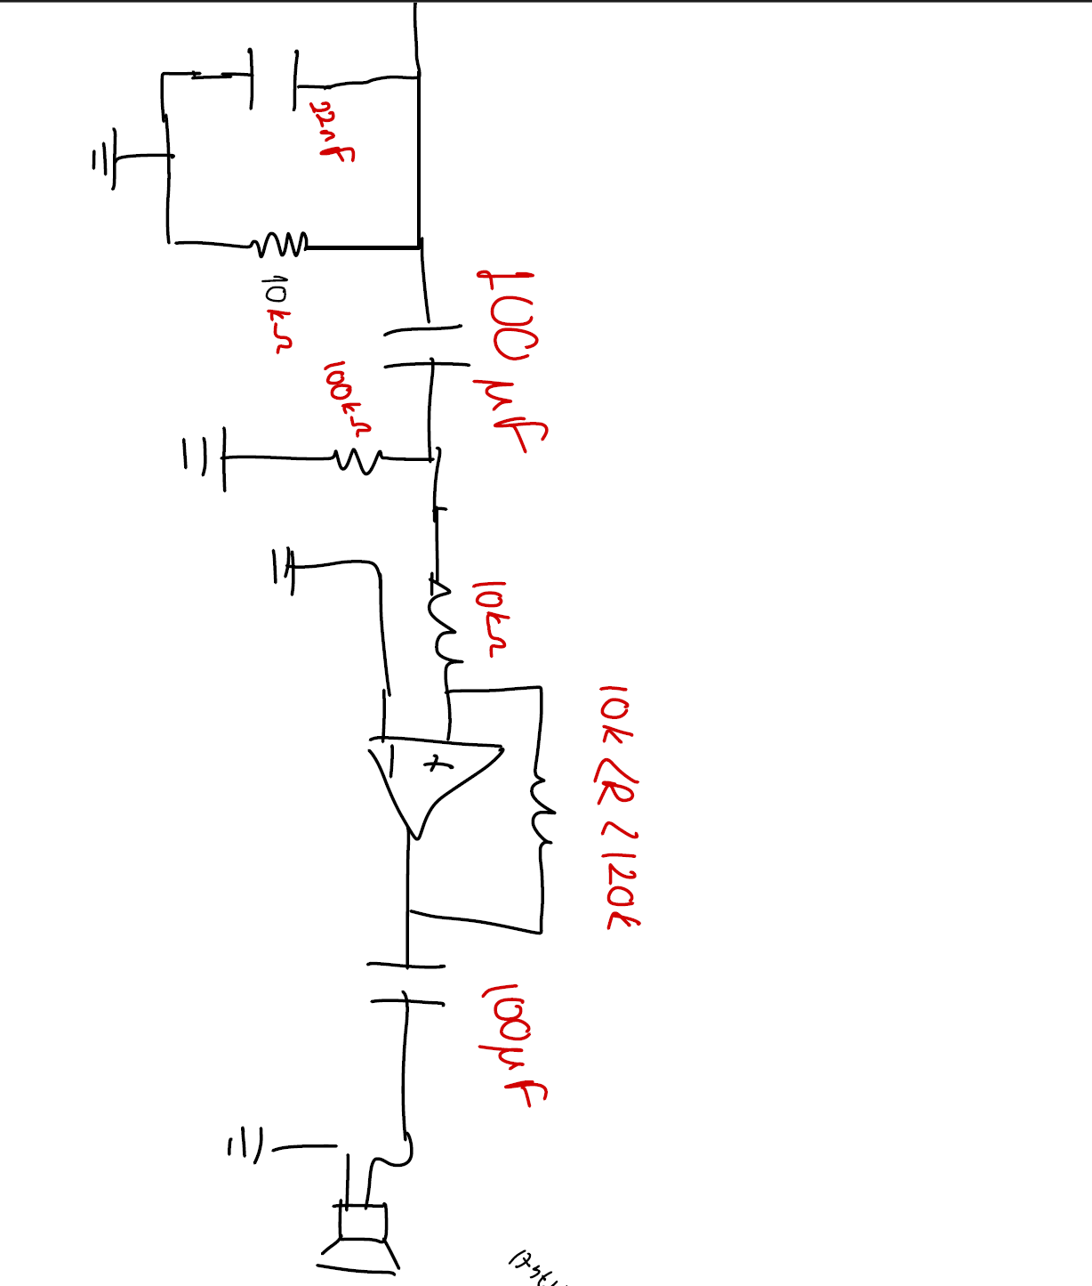

3. Data/Results
Part 1 – Building the Tuner and Amplification Stage
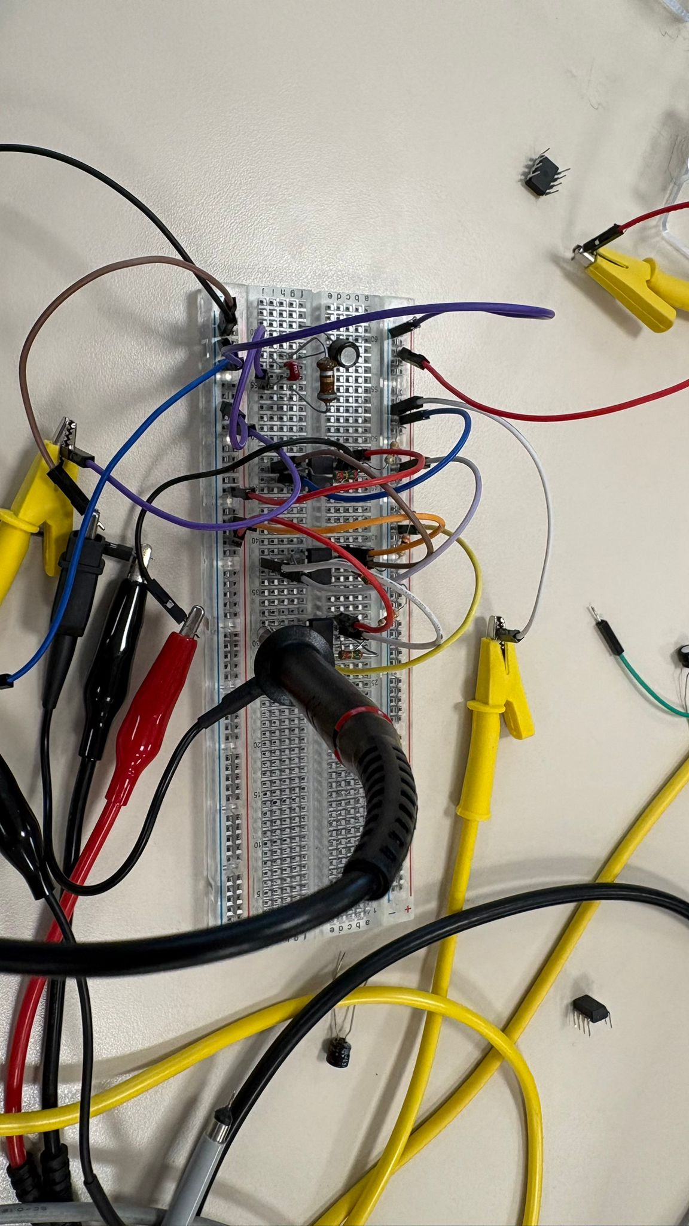
Figure 1: Tuner and Amplification circuit is built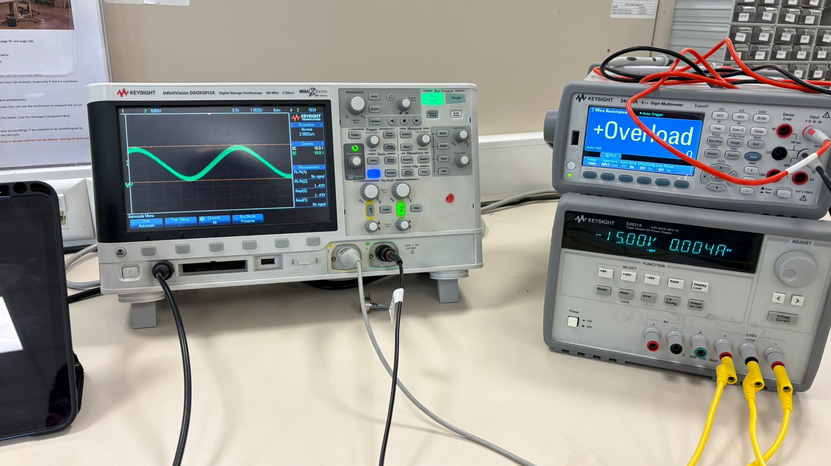
Figure 2: Measurements and amplification of 50mV peak to peak AC signal to 1.5 V peak to peak AC signal of 175kHz

Part 2 – Building the Detector Stage and Audio Amplifier
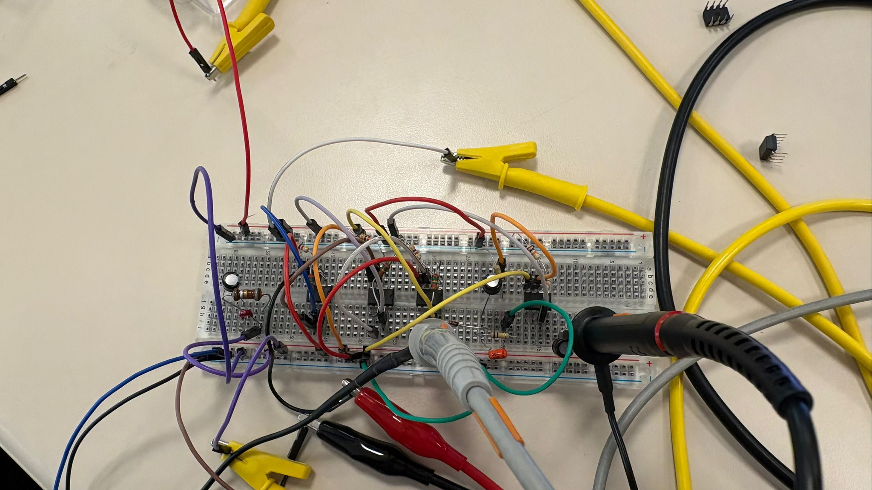
Figure 3: Detector circuit added to original circuit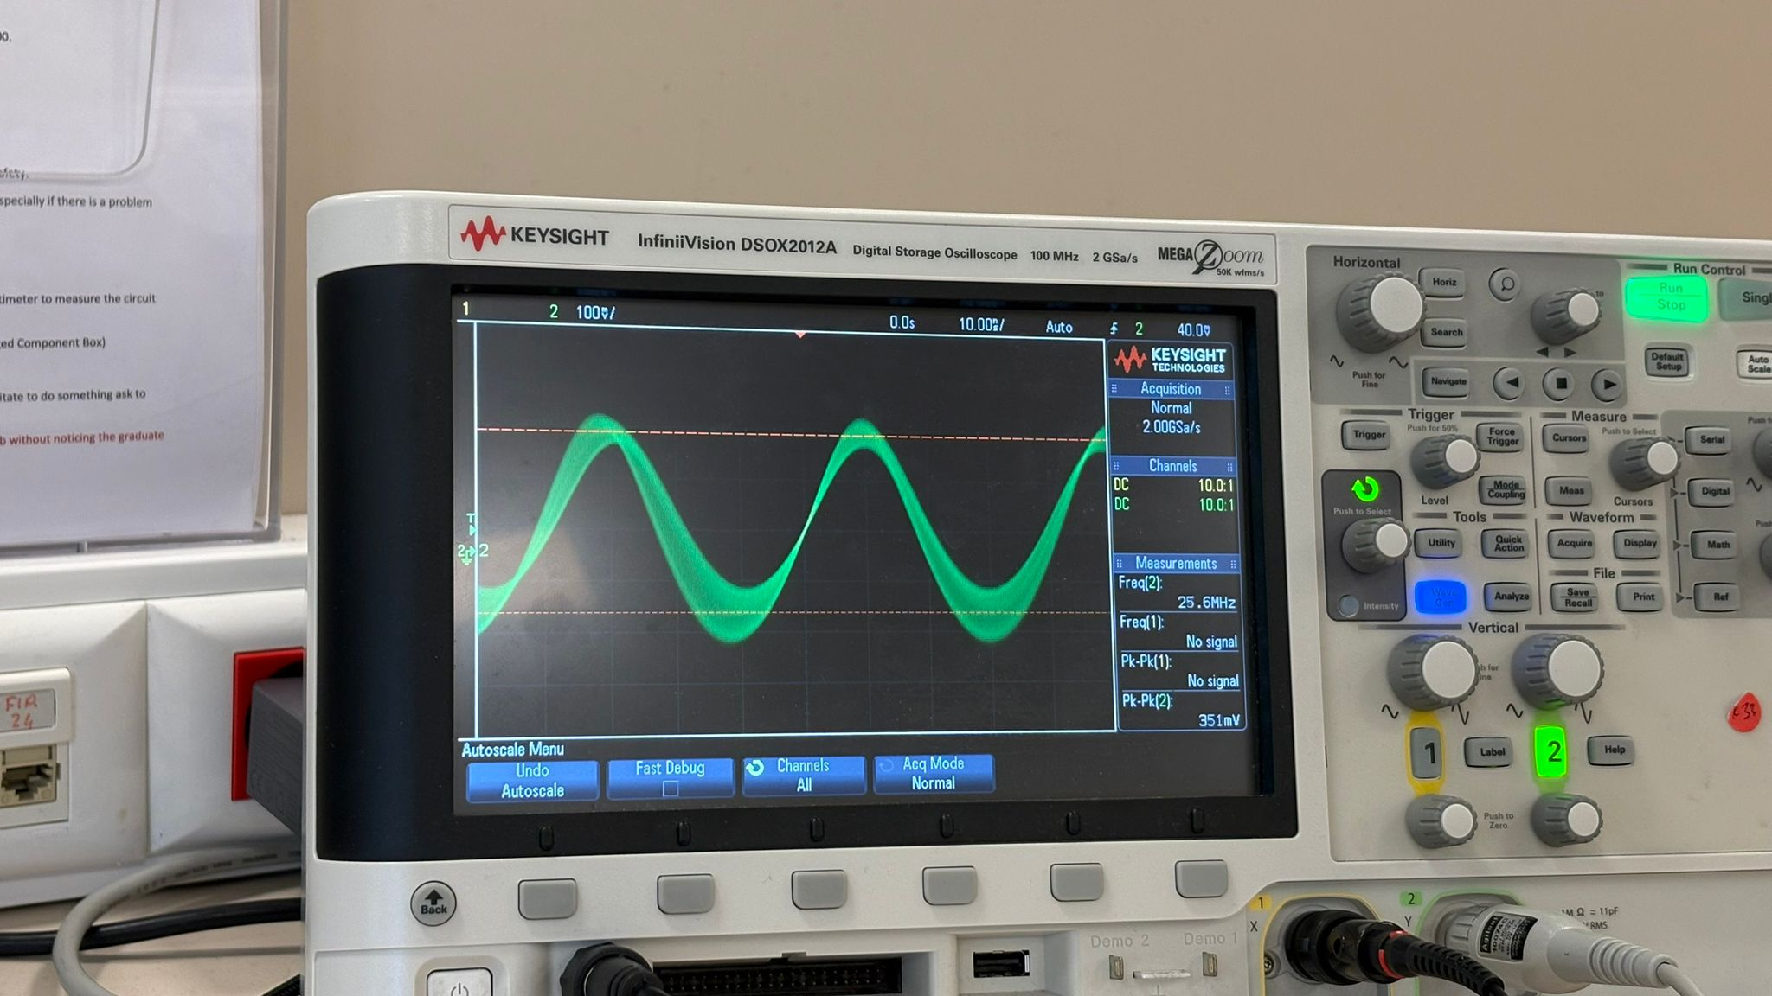
Figure 4: Measurements of the detector circuit using amplitude modulation function of the oscilloscope
Since I could not make detector circuit work, I don’t have any footage or measurements of the next stages.
4. Discussion
The experimental results obtained from the implementation of the radio receiver provide an analysis of signal processing through various electronic stages. In the first parts of the experiment, the tuner circuit successfully filtered the target carrier frequency, and the cascaded amplification stage increased the signal amplitude without exceeding the bandwidth limitations of the operational amplifiers. During the implementation of the detector, the expected demodulation was not observed. When verifying the complete integrated system, minor signal distortions and noise interference were observed compared to the theoretical waveforms. These variations can primarily be attributed to the tolerances of the physical components, environmental electromagnetic noise captured by the antenna, and the non-ideal characteristics of the operational amplifiers and the germanium diode. The implication of these variations for practical electronic circuit design is that engineers must account for noise suppression, impedance matching, and bandwidth limitations when cascading multiple active stages in a physical environment.
5. Conclusion
In this experiment, a complete amplitude modulation radio receiver was aimed to successfully analyzed and implemented. The lab work integrated fundamental electronic concepts, including resonance filtering, multistage amplification, and signal demodulation. The design specifications, particularly isolating a 175 kHz signal and extracting its audio envelope to drive a speaker, were achieved within acceptable margins. The transition from theoretical analysis to full system implementation highlighted the importance of testing and verifying individual stages before integrating a complex circuit. Overall, the experiment clarified the theoretical principles of radio receivers, demonstrating how selective filtering combined with proper amplification and detection results in a functional communication device.
Post-Lab
The use of three cascaded amplifier stages with a gain of five, instead of a single stage with a higher gain, was necessary due to the gain-bandwidth product limitations of the operational amplifiers. Since the product is constant at four megahertz, a single stage with a high gain would reduce the cutoff frequency well below the target operating frequency of 175 kHz, whereas cascading lower-gain stages preserves the required bandwidth for the carrier signal. To pass this specific frequency component, a parallel inductor-capacitor band-pass filter was utilized as the tuner. To design a multichannel receiver, this filter requires a variable capacitor or variable inductor to adjust the resonant frequency across different broadcasting stations. In the detection stage, the diode functions as a half-wave rectifier to pass only the positive cycles of the amplitude-modulated signal, while the parallel capacitor acts as a low-pass filter to smooth the output and remove the high-frequency carrier, leaving only the baseband audio envelope. The sound output from the speaker may not be very loud primarily due to the limited current-driving capability of the final operational amplifier or an impedance mismatch with the headphones, which can be improved by adding a dedicated audio power amplifier buffer or increasing the final voltage gain. Finally, if the diode in the detector is reversed, the receiver will still function properly; it will simply extract the negative envelope of the modulated signal, which results in an inverted audio waveform that sounds identical to the human ear.

